EENG 284 – Digital Design

Lab 09 – Mod 10 Counter

**2 Mod10 Counter**

Table 3: The truth table for the always/case logic inside the mod10counter.

|  |  |  |  |  |  |
| --- | --- | --- | --- | --- | --- |
| enb | synch | equalNine | muxSel | regEnb | roll |
| 0 | 0 | 0 | x | 0 | 0 |
| 0 | 0 | 1 | x | 0 | 0 |
| 0 | 1 | 0 | 0 | 1 | 0 |
| 0 | 1 | 1 | 0 | 1 | 0 |
| 1 | 0 | 0 | 1 | 1 | 0 |
| 1 | 0 | 1 | 0 | 1 | 1 |
| 1 | 1 | 0 | 0 | 1 | 0 |
| 1 | 1 | 1 | 0 | 1 | 0 |

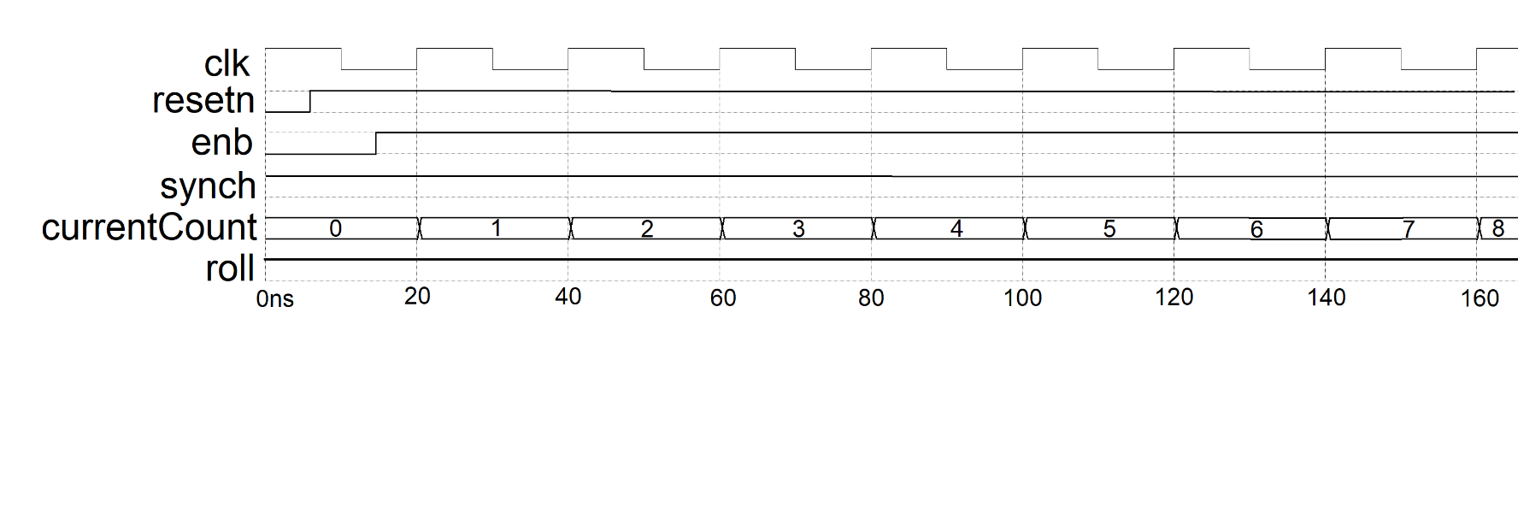

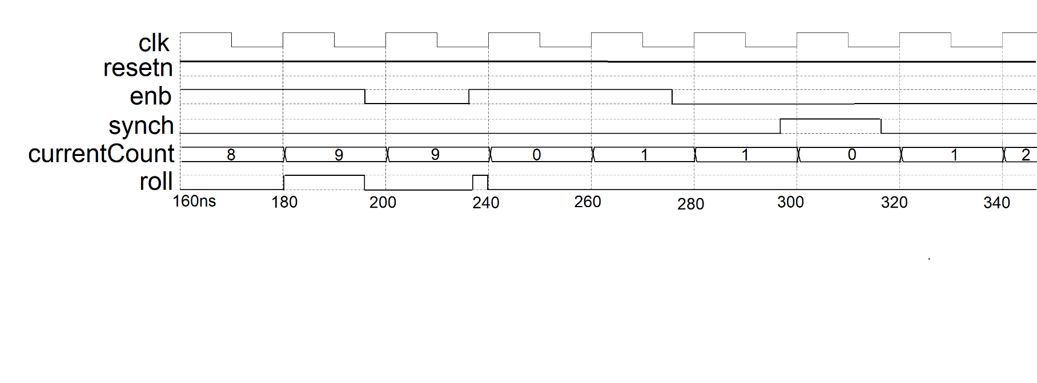

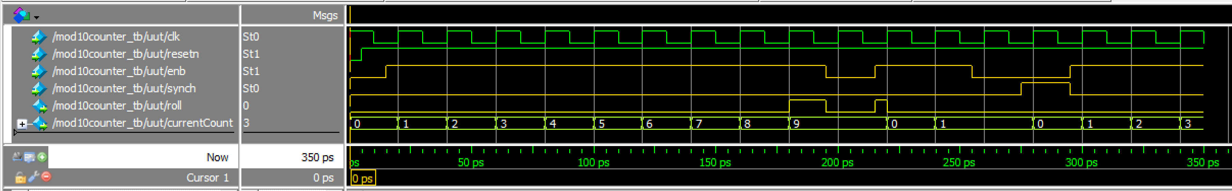

Testbench Waveform

Do File:

This should be located in the project folder, in the simulation folder, in the modelsim folder

(generated after the initial simulation is run)

vsim work.mod10counter_tb

restart -f

delete wave *

add wave -position end -color green sim:/mod10counter_tb/uut/clk

add wave -position end -color green sim:/mod10counter_tb/uut/resetn

add wave -position end -color gold sim:/mod10counter_tb/uut/enb

add wave -position end -color gold sim:/mod10counter_tb/uut/synch

add wave -position end -color yellow sim:/mod10counter_tb/uut/roll

add wave -position end -radix unsigned -color greenyellow sim:/mod10counter_tb/uut/currentCount